**“**[**Pugs**](https://www.thesprucepets.com/pug-dog-breed-profile-1117989)**”**

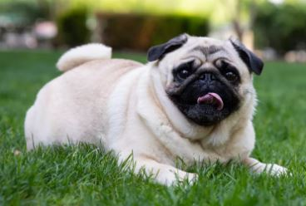

***Pugs are one of the most popular family dog breeds due to their sweet, friendly demeanor and manageable size. They're also one of the world's oldest breeds. The pug likely originated in China around 400 B.C. as a Tibetan Buddhist monk companion. Hypotheses swirl tying pugs to Tibetan mastiffs while others claim it's related to the Pekingese, another Chinese dog hailing from China.***

## “[Pekingese](https://www.thesprucepets.com/pekingese-dog-breed-profile-4685682)”

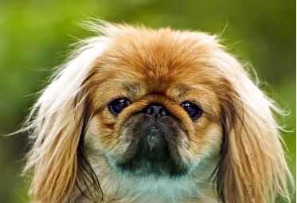

***Also called "Pekes," "lion dogs," or "sun dogs," Pekingese were initially kept as***[***companion pets***](https://www.thesprucepets.com/best-companion-dogs-4777657)***to Chinese royalty and were ingrained in Chinese folklore. One story says that Pekingese were created when Buddha shrunk a lion down to the size of a small dog. In reality, Pekingese were most likely the result of breeding a larger dog with toy-sized dogs in China. They were a favorite—and much looked-after—pet among Chinese royalty for thousands of years.***

**“**[**Shih Tzu’s**](https://www.thesprucepets.com/shih-tzu-dog-breed-profile-1117999)**”**

## dog no 3.JPG

## *The shih Tzu, a small toy dog with a playful personality, is named for its lion-like appearance. Its*[*Chinese name*](https://www.thesprucepets.com/chinese-dog-names-4846272)*comes from the word "lion." Like the Pekingese and pugs, Shih Tzus were treasured by Chinese nobility for centuries and were considered the noble dog of China. The shih tzu can be traced back to ancient dog breeds.*

## “[Shar-Peis](https://www.thesprucepets.com/shar-pei-dog-breed-profile-4689505)”

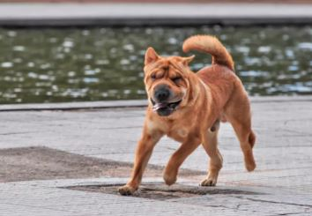

***Known for distinctive,***[***wrinkled***](https://www.thesprucepets.com/wrinkly-dog-breeds-4845400)***faces, petite ears, and blue-black tongues, shar-peis are a unique and rare breed with roots in ancient China. Shar-peis, meaning "sand skin," were initially bred as hunting and guard dogs 2,000 years ago in southern China. Sadly, during China's communist revolution in the mid-1900s, shar-peis populations were decimated, almost making the breed extinct. Sometime during the 1970s.***

## “[Chow Chow](https://www.thesprucepets.com/chow-chow-dog-breed-profile-1117956)”

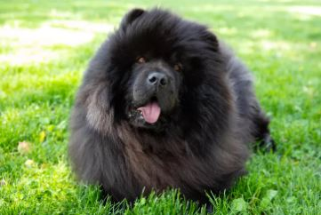

***Chow chows are among the most ancient Chinese dog breeds, with evidence dating back to 206 B.C. They were originally employed as hunting and guard dogs. Like the shar-peis, chows have a very***[***distinctive appearance***](https://www.thesprucepets.com/fluffiest-dogs-ever-4589343)***: Their faces are somewhat bear-like with deep facial folds and a blue-black tongue.***

## “[Chinese Crested](https://www.thesprucepets.com/chinese-crested-dog-breed-profile-4589181)”

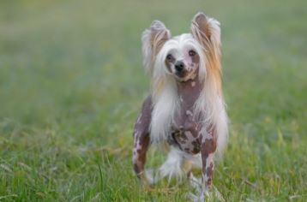

***Because the Chinese crested has extremely early origins, no one is exactly sure when or how the breed was developed. Some assume that hairless dogs from Africa were brought to China and bred with smaller, toy-sized dogs to give the crested its unique, hairless appearance. Chinese crested dogs were popular for use on Chinese trading vessels to hunt vermin.***

## “Xiasi”

## dog no 7.JPG

## *The Xiasi, pronounced "she-ah-seh" is a lean, muscular hunting dog that originated in the Guizhou region of China, sometime around 1080. Although the breed is typically used for hunting or guarding, it is widely believed in the Guizhou province that owning a Xiasi dog can bring wealth to the family.*

## “Kunming Wolfdog”

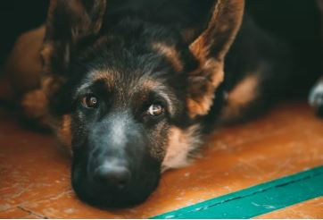

***A wolf-dog hybrid, the Kunming wolfdog, is thought to be related to***[***German shepherds***](https://www.thesprucepets.com/breed-profile-german-shepherd-dog-1117967)***introduced to China in the 1950s. It is sometimes called the Chinese German shepherd. Like German shepherds, Kunming wolfdogs are trained as military assistance dogs,***[***fire dogs, and search-and-rescue***](https://www.thesprucepets.com/types-of-working-dogs-1118684)***. they're also a popular family dog throughout China.***

## “Formosan Mountain Dog (Taiwan Dogs)”

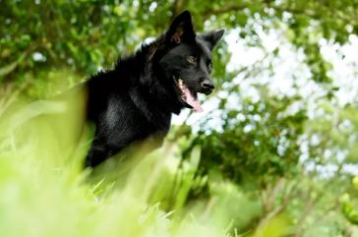

***Formosan mountain dogs or Taiwan dogs are one of the oldest and most primitive dog breeds in the world. The Formosan mountain dogs are small- to medium-sized dogs that hail from south Asian dog stock in the Taiwanese mountains. Although Formosan mountain dogs were once considered wild, they're now domesticated as hunting dogs, guard dogs, rescue dogs, and family dogs.***

## “[Japanese Chin](https://www.thesprucepets.com/japanese-chin-full-profile-history-and-care-4685097)”

## dog no 9.JPG

***Despite its name, the Japanese chin is believed to have originated in China. Closely related to Tibetan spaniels, they were likely a gift from the Chinese emperor to Japanese royalty. Known for their cat-like, calm, and affectionate behavior, the Japanese chin became extremely popular among Japanese nobility over 1,000 years ago.***

## “Chinese Imperial”

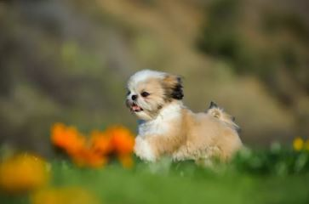

***related to the shih Closely Tzu, the Chinese imperial dog is also known as a teacup or micro shih Tzu. It is considered by many to be a separate Chinese breed, although not by the AKC, which calls it a small shih Tzu. As its name implies, this was possibly another small companion dog kept by dynastic Chinese emperors.***

## “Chinese Chongqing”

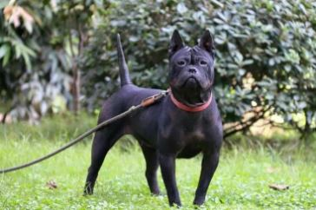

***This breed after the city of Chongqing has a wrinkly face similar to a shar-pei, a signature look for many Chinese breeds. This rare hunting and guardian dog breed is rare in modern China but still exists in some rural areas. It is believed to have first appeared 2,000 years ago during the Han dynasty in southwestern China. It is sometimes called the bamboo ratter due to its unusual tail that looks like a straight, slender, and hairless bamboo stick.***

## “Laizhou Hong”

## dog no 13.JPG

## *Also known as the Chinese Red Dog, Laizhou Hong pups have gorgeous red coats (“hong” means red) and tall, pointed ears. It’s believed these dogs were bred by combining indigenous Chinese breeds with German Shepherds and Rottweilers in the 19th century.*

## *“*Lhasa Apso”

## dog no 14.JPG

***Though affectionate and resilient, these tiny pups aren’t afraid to go full watchdog mode. Lhasa Apso dogs are very protective and may bristle at new people or animals. Since they are definitely smarty pants, exercising their minds is as important as exercising their bodies. This can be done during playtime, long walks and agility training.***

## “Shaanxi Xian Hound”

## dog no 15.JPG

***Shaanxi Xian Hounds have been around for***[***at least 2,500 years***](http://old.cku.org.cn/nativedog/qinxian.html)***, according to the China Native Breed Conservation Club. These tall, elegant canines are likely the ancestors of Greyhounds and Afghan hounds. Bred to chase and hunt, their bodies are aerodynamically designed for optimal speed. Though calm when not in motion, Xians are independent and respond only to those they know and love best.***

*“***Tibetan terrier”**

## 

## *The sensitive and affectionate Tibetan terrier is not really a terrier at all. As you can see from their unique appearance, they hardly share any qualities with the terriers we’re familiar with in the West. They have a unique double coat with a wooly undercoat* *and ultra-long topcoat, and snowshoe-like feet.*

## “Tibetan Mastiff ”

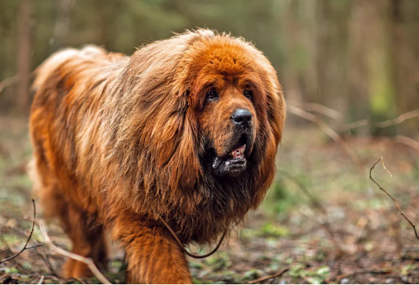

## *Many Tibetans believe*[*Tibetan mastiffs*](https://www.dailypaws.com/dogs-puppies/dog-breeds/tibetan-mastiff)*are host to the souls of monks and nuns who weren't reincarnated into people or crossed over into a heavenly realm. Fittingly, the breed protected Himalayan villages and their residents and were often gifted to Tibetan travelers.*

## “Chinese Imperial”

## dog no 18.JPG

## *Closely related to the Shih Tzu, the*[*Chinese Imperial Dog*](https://wagwalking.com/breed/chinese-imperial-dog)*is considered by many to be a separate Chinese breed. As its name implies, this was another small dog kept by the royal families of China throughout the dynasties.*

## “Kunming”

## *dog no 19.JPG*

## *Much like American police K9-units utilize German Shepherds, the*[*Hong Kong police use Kunming dogs*](https://www.scmp.com/news/china/science/article/3002346/chinas-first-cloned-police-dog-reports-duty)*(also called Kunming Wolfdogs). The two*[*breeds are believed to be cousins*](https://animalso.com/breeds/kunming-wolfdog/)*because they look similar and have similar personality traits.*

### “Laizhou Red”

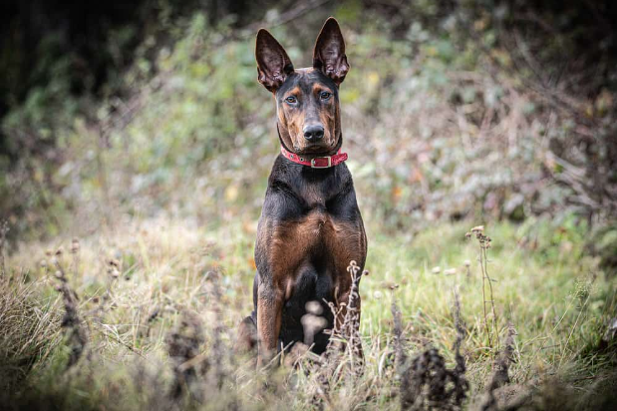

***This breed was created in Shandong in the 1970s. They were bred with***[***Great Danes***](https://betterpet.com/great-dane/)***for their size, along with local dogs for their stamina. Unfortunately, they quickly fell out of favor once China allowed foreign breeds to be bought and sold within its borders by the public.***